Cobblestone Quilters Guild
P.O. Box 42864 • Charleston, SC 29423
http://cobblestonequilters.com

Established in 1983 to foster the art of quilting, to encourage a high standard of design and technique in all of its various forms, and to stimulate an interest in these goals within the South Carolina lowcountry community.

August 2021 Newsletter
Contents

President’ Message……………………………………………………………………………………………1
Treasurer’s Report …………………………………………………………………………………………….2
Minutes – Guild Meeting, Thursday, May 13…. …………………………………………………………...2
Announcements …………………………………………………………………………………………....…4
2021 CQG Board Members……………………………………………………………………………….….6
2022 Quilt Show Committee Members…………………………………………………………………..….7
2022 Quilt Show Sponsors and Vendors…………………………………………………………………...7
Membership form ……………………………………………………………………………………………..13
Check Reimbursement form …………………………………………………………………………….…..14

President’s Message

From the President’s Sewing Room:

WE ARE GOING LIVE and IN PERSON!!
I am so excited to share that our August meeting will be held at Yeaman Park Presbyterian Church!!! We will be together again!!
We have a celebration planned…..ice cream and cookies! We know everyone will be excited to see each other so we will have a nice social time together.
Covid Show and Tell…..we want to see everything sewed and quilted during our lock down.
Plus, a live and in-person program by our former member Jennifer Ley, who is traveling down from West Jefferson, NC, to share her adventures into fiber arts, raising alpacas, spinning wool, and everything that has happened in her life since she moved away.
We will keep the business part of the meeting as brief as possible, but there will be a report from the Facility/Meeting committee with their recommendations.
We need a good estimate of how many will be in attendance in order to get the ice cream and cookies, so please, if you are on the FB CQG group answer the poll there. If you are not on FB then text me at 843-834- 3195 or email me at kkendo52@gmail.com if you are planning to attend.
We will also livestream the meeting on FB for those who can’t attend.
Doors will open as usual at 6:30 PM. Give the board time to get the room set up!!!
I feel like dancing in the street!!!
Karen Kendo– who is very sick of zoom. LOL
Treasurer’s Report June 2021

CQG Bank Balance 05/31/2021 | 32,718.49
Income:
Programs (B. Brackman - donations other groups) | 210.00
Programs (Classes - Sulky workshop) | 320.00
Membership | 40.00
2022 Beach Retreat Deposits | 3,300.00
TOTAL | 3,870.00
Expenses:
2021 Beach Retreat Refund | 300.00
2022 Beach Retreat Overpayment | 20.00
Programs (B. Brackman) | 300.00
Programs (Classes - Sulky workshop kits) | 180.63
TOTAL | 800.63
Ending Balance: | 35,787.86
Money Market Reserve: | -25,009.00
ENDING BALANCE: | 10,778.86
Respectfully submitted and available for audit upon request
Donnita Cook, Treasurer
dcook@sc.rr.com

Minutes – Guild Meeting, Thursday, July 8, 2021

Karen Kendo, the President, welcomed all of the Guild members to the Zoom Meeting.

Membership Report: The Guild currently has 144 active members and 101 members on Facebook.

The Minutes from the last meeting were approved by the attending members. Motion to approve by Marva Hayne and seconded by Barbara Troeger.

Treasurers Report: The Treasurer’s report is posted in the newsletter each month. If you have any questions, please contact Donnita Cook.

Program: Julie Sander introduced the Sulky Program, presented by Eric Drexler, who is the son of the founders of the Sulky Company. Also present was one of Julie’s contacts at Sulky Corporate Office, Leann Jones. The presentation included information on threads, needles, stabilizers, and website. A 25% coupon was distributed to the membership by Julie. It is good from July 8th to July 29th for anything on Sulky’s website. When using the coupon, 10% is given back to the Guild. Check out the website: Sulky.com for more detailed information. Joyce Greer won the door prize from Sulky.

Facility Committee: The committee will be meeting on Saturday, July 10th. Karen Kendo is still waiting to hear back from Yeaman Park Church regarding in person meetings at their facility. The Church council is meeting in July. All of the options will be presented to the general membership for consideration.

Nominating Committee: Volunteers are needed to be on this committee to contact membership for board positions for the 2022 calendar year. Please contact Karen if you would like to serve on this committee. Any executive board members or committee chairman that would like to remain for the 2022 year, please let Karen or another member of the executive board know.

Show and Tell: Julie Sander’s quilts for family members were displayed.

Community Outreach: Barb Troeger informed membership that she will be at the storage unit on Wednesday, July 14th to collect and donate quilts. Diane Mercer and Sheila Moore will join to help filter and organize existing donations. Please let Barb know if any members know families in some need who could benefit from comfort quilts.

Carolina Fair: Donna Walters mentioned that the Coastal Carolina Fair is coming up in October. Please check newsletter for more information and let Pat Schneider or Donna Walters know about volunteering for the event.

Upcoming Programs: August, How My Fiber Hobby Took Over My Life, with Jennifer Ley. September, June Bohac’s trunk Show. October, Studio Tours of Membership. November, All About Sashings. December, Party to be determined.

Karen Kendo adjourned the meeting.

Respectfully submitted by Barbara Troeger

ANNOUNCEMENTS

UFOs
Hello Cobblestone UFO participates,
We are seven months into the year and the completed UFOs are increasing and they are beautiful! There are only five months left to submit completed UFO pictures and notifications to me via email so you will get credit for your completed project. I look forward to seeing your wonderful creations!

Cheryl Wheeler
cherylwheeler8@gmail.com

August Giant Block of the Month
Of course, I’m behind again. The directions can be found here. This one looks really easy!
https://shop.kitchentablequilting.com/collections/freebies/products/august-giant-block-tutorial

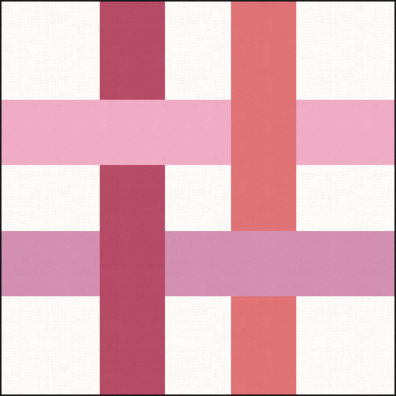

Community Outreach

Community Outreach has been busy in July with sorting and organizing donations in the storage unit at Ladson. Members have been stopping by to help, pickup quilts for longarm services, drop off finished quilts, and take quilts for distribution. Thank you… Laurie Carr, Sheila Moore, Luann Fischer, and Diane Mercer. You have been an incredible help.

So far in July, we have donated 20 quilts to Home of Hopes and Hopes House which supports homeless men and women with services. We also donated 2 quilts to a family who lost their husband/father and 2 quilts to a family whose father is undergoing cancer treatment. We also donated to a family who lost their son...5 comfort quilts to young toddlers, parents and siblings, and an uncle who is undergoing chemotherapy. Thanks to Donna Priest Walters, Luann Fischer, and Susan Schumm for bringing these families to my attention.

***IF YOU KNOW OF ANY PERSON OR FAMILY THAT CAN BENEFIT FROM A COMFORT QUILT, PLEASE LET ME KNOW.

We are trying to get together 1 yard pieces of fabric and backing, both for kids and adults, to bring to either the August or September meeting for people to pick and choose any three fabrics (or five fabrics) to make charity quilts. Remember you get to pick the 1 yard pieces to put together. Also, there will be patterns for you to choose from as well. Of course, you can always use your own patterns.

I am excited to see all of you!

BUSY HANDS ARE HAPPY HEARTS!!!

Barb Troeger
Community Outreach
Barb83189@gmail.com

Newsletter

Please submit anything you might have for the newsletter no later than the 20th of the month for publication the following month. Please email submissions to Pat Schneider at dditchquilter@gmail.com with “newsletter” in the subject line.

REMEMBER that we do a good deal of communicating via the Guild’s Facebook page. If you want to be included, send a request to join on the Guild’s page.
Pat Schneider – dditchquilter@gmail.com – 843-860-1263

THE COASTAL CAROLINA FAIR IS RETURNING!!!

The 2021 Coastal Carolina Fair will be open from Friday, October 28, through Sunday, November 7. The Guild, along with other local crafts organizations, has a table in the Creative Arts Building every year. We “man” the table during the Fair in order to promote the art of quilting, which is part of our mission statement. Volunteers are encouraged to bring quilting projects to work on while there. Machines are allowed and an electrical drop will be provided. Information about the Guild, and our upcoming quilt show, will be available to distribute to visitors.

Volunteers will be given a pass for each day they volunteer. Arrangements to get passes to Guild members will be planned as we get closer to the Fair dates.

I will have Fair sign up sheets at the AUGUST meeting!!

Pat Schneider
dditchquilter@gmail.com

From one of our advertisers:

Part-Time Office Associate Position
Morningstar Storage Oakbrook
4400 Ladson Rd, Summerville, SC 29485
Office Associate: assists in day-to-day operations under the direction of the Property Manager.
Promotes Morningstar Storage, leases units, process payments, process move-outs, promote sales of merchandise, etc.
Part-time schedule consists of three weekends per month and one to two days per week averaging 21 hours per week. Schedules are set with the Property Manager and are created monthly. If interested, please apply on-online at…
www.morningstarstorage.com Location: #365 Oakbrook

We appreciate your business!
Ask me about how you can receive $50 off your next month’s rent.
Ron Pell | Property Manager
Valerie Wiliams – Office Associate
Morningstar Storage of Ladson
3772 Ladson Road
Ladson, SC 29456
Office: 843-242-7771
http://www.morningstarstorage.com/location/340/sc/ladson/ladson/

Cobblestone Quilters Guild 2021 Board and Committees

President Karen Kendo 843-834-3195 kkendo52@gmail.com
Vice President June Bohac 843-708-0554 bvjcruise@gmail.com
Treasurer Donnita Cook 843-696-1956 dcook@sc.rr.com
Secretary Becky Haines 440-371-9405 rebubba@hotmail.com

Beach Retreat Melissa Pate and Mary Majestic
BOM Coordinator Karen Kendo
Coastal Carolina Fair Pat Schneider
Community Outreach Barb Troeger
Historian Linda Ambrose
Hospitality Cathy Spence
Membership Pat Schneider
Newsletter Pat Schneider
Parliamentarian Virginia Schrenker
Programs Julie Sander, Michelle Zahn, Wendy Fernau
Quilters’ Day IN Karen Kendo
Quilters’ Treasure Pat Riddle
Scholarships Mary Majestic
Tea and Sympathy Pat Perry
UFOs Cheryl Wheeler
Web Mistress Martha Ferguson
2022 Quilt Show Melissa Pate and Mary Majestic

2021 open position: Ways and Means – Please contact Karen Kendo if you are interested in filling this position.
2022 QUILT SHOW COMMITTEE

Chairperson Melissa Pate pate7245@gmail.com
Treasurer Becky Haines rebubba@hotmail.com
Secretary Mary Majestic mommajic@aol.com
Admissions Dominique Gibson domann17@gmail.com
Appraiser Evelyn Richards itsevelyn64@outlook.com
Bed Turning Demonstration Christine Taylor chrisquilts@mac.com
Charity Basket Walk Debra Busby dkbusby@hotmail.com
Facebook account Pat Schneider dditchquilter@gmail.com
Hospitality Wendy Fernau wjfernau@aol.com
Judging Corky Ledbetter cledbetter@gmail.com
Museum Quilt Pat Schneider dditchquilter@gmail.com
Program and Quilt Labels Evelyn Richards itsevelyn64@outlook.com
Publicity Pat Schneider dditchquilter@gmail.com
Quilt Hanging and Take Down Marva Hayne marva.hayne@gmail.com
Quilt Intake and Return Karen Kendo kkendo52@hotmail.com
Quilt Registration Corky Ledbetter cledbetter@gmail.com
Raffle Quilt Tickets Julie Sander sanderjulieb@gmail.com /
Wendy Fernau wjfernau@aol.com
Ribbons and Awards Kim McPeake kmcpeake@gmail.com
Signage Linda Ambrose linda.ambrose51@gmail.com
Sponsors and Vendors Pat Schneider dditchquilter@gmail.com
Staffing Mary Majestic mommajic@aol.com
Viewers’ Choice Sheila Moore smoore1320@yahoo.com
Ways and Means Donna Walters donnam@walterscom.net
Website Martha Ferguson marthaferguson@mac.com

2022 QUILT SHOW SPONSORS
Carolina Quilt Studio www.carolinaquiltystudio.com
Dragonfly Quilt Shop www.dragonflyquiltshop.com
Fashion Fabrics on Facebook at Fashion Fabrics of Mt. Pleasant
Five-Eighth Seams www.fiveeighthseams.com
People, Places & Quilts www.PPQuilts.com
Quilter’s Gallery https://quiltersgallery.net
Schoolhouse Quilts www.schoolhousequiltsnc.com
Sew Suite Studio www.sewsuitestudio.com
Wild and Wooly www.thewildandwooly.com

2022 QUILT SHOW VENDORS
Dyes Happy Empty Pockets Alpaca
French Connection High Sewciety Boutique
Kathy’s Patchwork Loving Stitches
The Machine Lady Marcia Layton Designs
Midway Wool Otavalo Textiles
Quilter’s Treasure StashTools
Susan Edmonson Designs Thimbles for You
U Can Quilt Yadkin Valley Quilts
Steel on Stone Sharpening

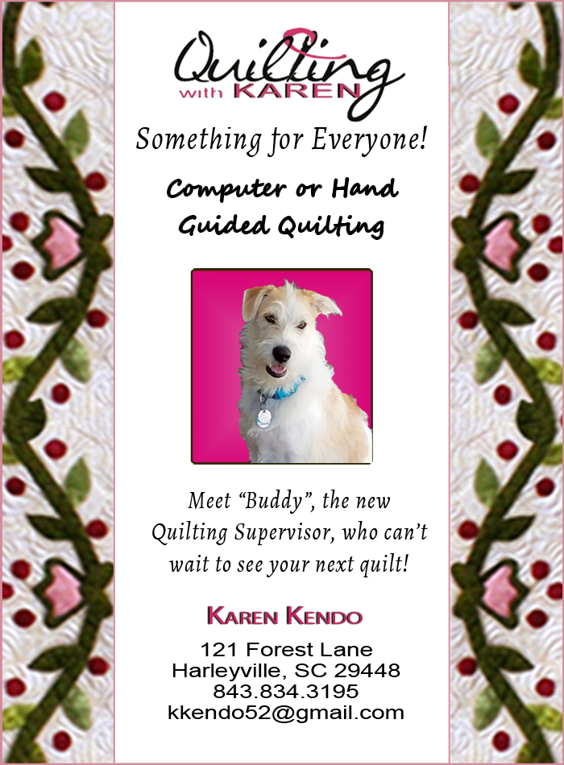

COBBLESTONE QUILTERS GUILD IS GRATEFUL FOR THE CONTINUED SUPPORT OF THE LOCAL BUSINESSES WHO ADVERTISE IN OUR NEWSLETTER. PLEASE SUPPORT LOCAL BUSINESSES.

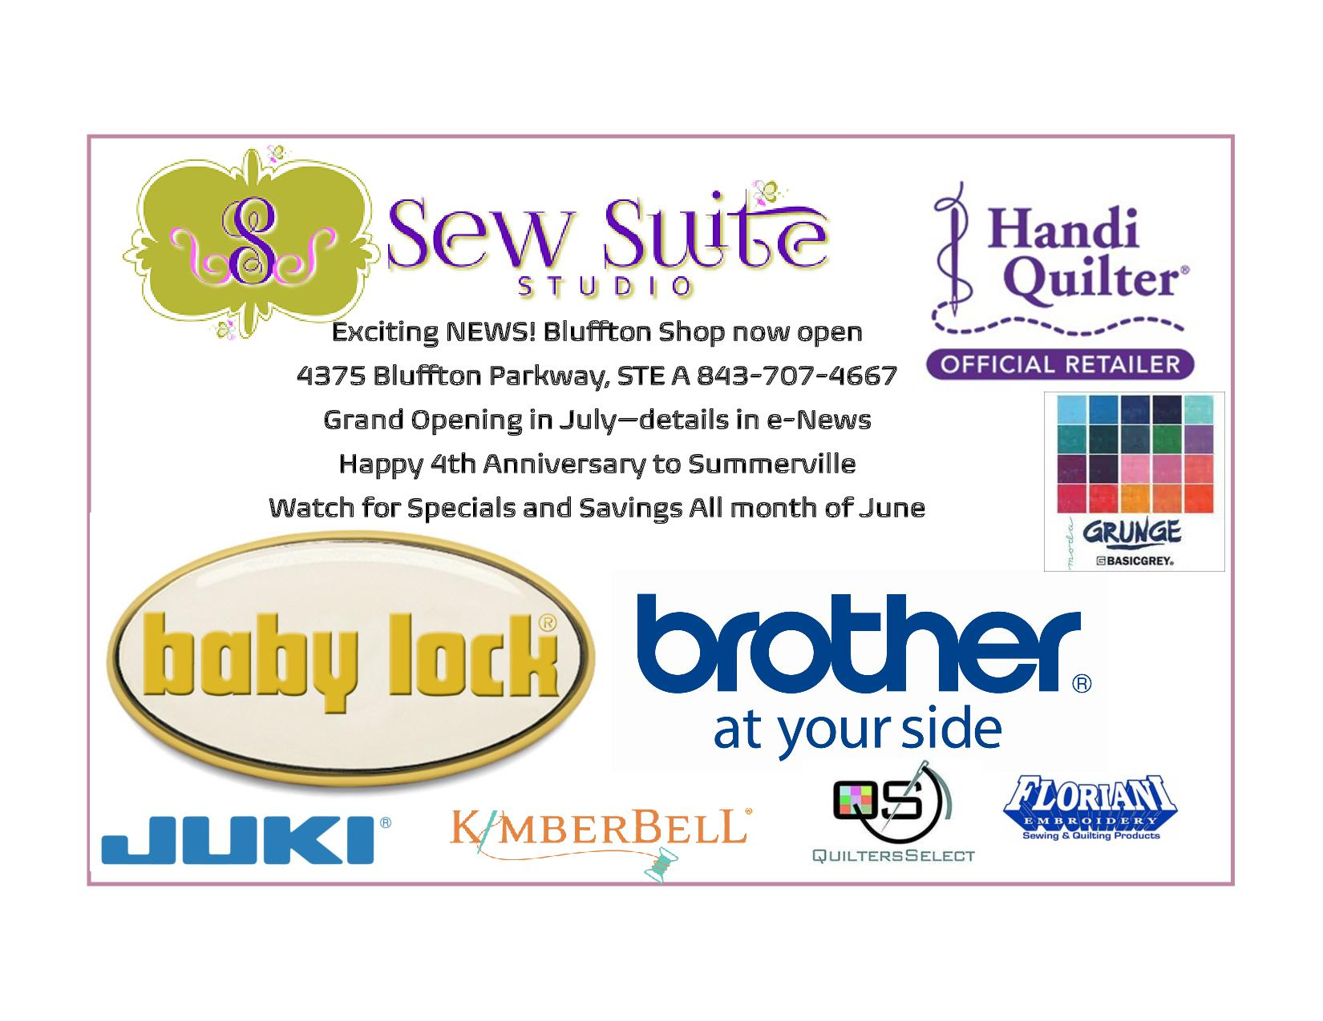

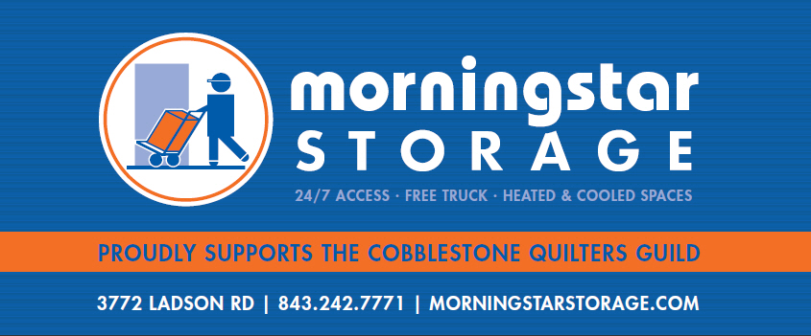

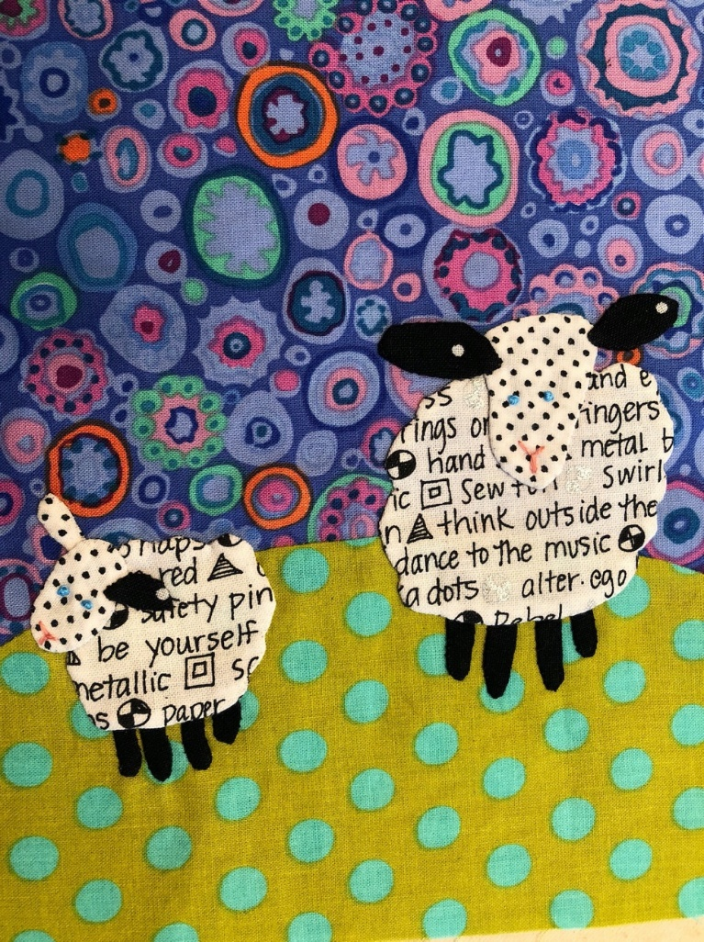
Wild and Wooly
Quilting • Knitting
Sewing • Crocheting Notions • Classes
1212 Chuck Dawley Blvd.
Mount Pleasant, SC 29464
(843) 881 5588
www.thewildandwooly.com
contactus@thewildandwooly.com

OFFICIAL USE ONLY
Date: __________________
Amt:___________________
CASH: $_____________
CHECK #: ___________
Membership Card
______ Mailed in SASE

Cobblestone Quilters Guild
www.cobblestonequilters.com

MEMBERSHIP 2021: RENEWAL____ or NEW_____
PLEASE PRINT CLEARLY / FILL OUT COMPLETELY

NAME: ________________________________________________________________ (As it will appear in directory)
ADDRESS: _____________________________________________________________
CITY: ___________________________ STATE: ______ ZIP: ____________ Birthday (Month and day) ___________
Cell Phone: ________________________________ Home Phone: ____________________________
EMAIL ADDRESS: ___________________________________________________________________
Please PRINT EMAIL ADDRESS CAREFULLY to ensure delivery of your Guild Newsletter.

Make check payable to
COBBLESTONE QUILTERS GUILD
Mail completed form to:
Cobblestone Quilters Guild
Post Office Box 42864
Charleston, SC 29423
Renewing Member from BEFORE 7/1/2020: NO 2021 DUES
OR New or Renewing Member AFTER 7/1/2020: ($40.00) ______________
Optional Tax Deductible Donation: ______________
TOTAL: ___________________

2021 Newsletter Login information will be on the BACK OF YOUR MEMBERSHIP CARD
If you are a NEW member, or you were not a PAID member of CQG as of July 1, 2020, dues are $40.00. If sending in a new membership form is AFTER JULY 1, dues are HALF PRICE ($20.00). Please send this completed form to the PO Box, WITH A SELF-ADDRESSED, STAMPED ENVELOPE, and you will receive back your 2021 membership card.
If you have any questions, please send an email to Pat Schneider, Membership Chair, at dditchquilter@gmail.com.

Cobblestone Quilters’ Guild
Reimbursement Form

(No checks will be written at guild meetings. Please email check information to the treasurer prior to the meeting or the check will be mailed to you after the meeting date.)
Please fill out this form and submit to the Cobblestone Treasurer with all receipts attached.
Committee: _____________________________________ Date: __________________
Name: _____________________________________ Phone: __________________
Address if reimbursement is to be mailed to you:
__________________________________________________
__________________________________________________
Expense Details (Item, purpose, amount):
___________________________________________________ $ __________________
___________________________________________________ $ __________________
___________________________________________________ $ __________________

Total $__________________
NOTE: NO CHECKS WILL BE ISSUED WITHOUT A COMPLETED REIMBURSEMENT FORM

Treasurer’s Notes:
Date: ___________________________ Check Number: ___________________

